**Terraform**

Terraform is a popular infrastructure-as-code tool that allows you to automate the provisioning and management of infrastructure resources. It uses configuration files written in the HashiCorp Configuration Language (HCL) to define the desired state of your infrastructure, and it uses various commands to apply those configurations and manage your infrastructure resources.

**How Does Terraform Work?**

With Terraform, users can define infrastructure resources using a simple, declarative configuration language. These resources can include virtual machines, networking components, storage resources, and more. Once the configuration is defined, Terraform can be used to create, modify, and destroy these resources in a repeatable and predictable way.

One of the key benefits of Terraform is its ability to support multiple cloud providers, as well as on-premises and open-source tools. This means that users can define infrastructure resources using a single configuration and use Terraform to manage resources across different environments.

Overall, Terraform is a powerful and flexible tool that enables users to define and manage infrastructure resources in a reusable and automated way. It is widely used in a variety of industries and scenarios, including cloud infrastructure, data centers, and hybrid environments.

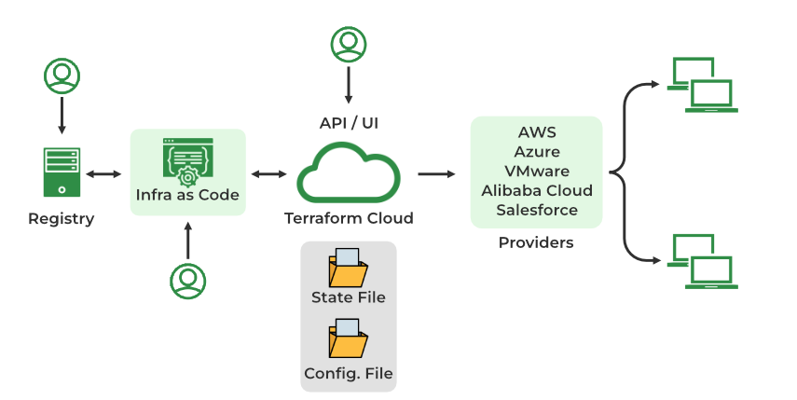

**Components of Terraform Architecture**

**Terraform Configuration Files**

These files contain the definition of the infrastructure resources that Terraform will manage, as well as any input and output variables and modules. The configuration files are written in the HashiCorp Configuration Language (HCL), which is a domain-specific language designed specifically for Terraform.

**Terraform State File**

This file stores the current state of the infrastructure resources managed by Terraform. The state file is used to track the resources that have been created, modified, or destroyed, and it is used to ensure that the infrastructure resources match the desired state defined in the configuration files.

**Infrastructure as Code**

Terraform allows you to use code to define and manage your infrastructure, rather than manually configuring resources through a user interface. This makes it easier to version, review, and collaborate on infrastructure changes.

**Cloud APIs or other Infrastructure Providers**

These are the APIs or other interfaces that Terraform uses to create, modify, or destroy infrastructure resources. Terraform supports multiple cloud providers, as well as on-premises and open-source tools.

**Providers**

Terraform integrates with a wide range of cloud and infrastructure providers, including AWS, Azure, GCP, and more. These providers allow Terraform to create and manage resources on those platforms.

Overall, the architecture of a Terraform deployment consists of configuration files, a state file, and a CLI that interacts with cloud APIs or other infrastructure providers to create, modify, or destroy resources. This architecture enables users to define and manage infrastructure resources in a declarative and reusable way.

**Terraform Modules**

In Terraform, a module is a container for a set of related resources that are used together to perform a specific task. Modules allow users to organize and reuse their infrastructure code, making it easier to manage complex infrastructure deployments.

Modules are defined using the ‘ **module**‘ block in Terraform configuration. A module block takes the following arguments:

* **source**: The source location of the module. This can be a local path or a URL.
* **name**: The name of the module. This is used to reference the module in other parts of the configuration.
* **version**: The version of the module to use. This is optional and can be used to specify a specific version of the module.

Inside a module block, users can define the resources that make up the module, as well as any input and output variables that the module exposes. Input variables allow users to pass values into the module when it is called, and output variables allow the module to return values to the calling configuration. Modules can be nested, allowing users to create complex infrastructure architectures using a hierarchical structure. Modules can also be published and shared on the Terraform Registry, enabling users to reuse and extend the infrastructure code of others.

**What is Terraform Core?**

The open-source binary for Terraform Core is available for download and usage on the command line. The configuration files you provide (your desired state) and the present state (a state file generated and managed solely by Terraform) are the two input sources used by Terraform’s Core. The Core then develops a plan for what resources need to be added, altered, or eliminated using this knowledge.

**Why Terraform?**

Terraform offers many benefits and it is a widely used tool in present organizations for managing their infrastructure.

**Multi-Cloud And Multi-Provider Support**

Terraform can manage multi-cloud at a time like [Amazon Web Services (AWS)](https://www.geeksforgeeks.org/introduction-to-amazon-web-services/), [Azure](https://www.geeksforgeeks.org/introduction-microsoft-azure-cloud-computing-service/), and [Google Cloud Platform(GCP)](https://www.geeksforgeeks.org/what-is-google-cloud-platform-gcp/) and also you can manage your on-premises infrastructure. The language used in terraform was Hashi Crop Language (HCL).

**Terraform Is Declerative Mangement Tool**

There is no need to tell Terraform how to achieve the desired step-by-step you can just mention the desired state you want Terraform will automatically achieve that. So that the terraform is called a declarative management tool.

**Mutable and Immutable Infrastructure**

Mutable infrastructure refers to upgrading the software by modifying the existing one. Immutable infrastructure refers to infrastructure that is never modified once it is created which one to choose will depend upon us.

**State Management**

Terraform logs(maintains) information about the resources it has created in a state file( terraform. tfstate). This enables Terraform to know which resources are under its control and when to update and destroy them.

**Private Module Registry**

A private module registry is a repository for Terraform modules that is only accessible to a specific group of users, rather than being publicly available. Private module registries are useful for organizations that want to manage and distribute their own infrastructure code internally, rather than using publicly available modules from the Terraform Registry.

To use a private module registry, users need to configure their Terraform CLI to authenticate with the registry and access the modules. This typically involves setting up an access token or other authentication method and specifying the registry URL in the Terraform configuration.

Once configured, users can use the ‘ **module**‘ block in their Terraform configuration to reference the modules in the private registry, just like they would with publicly available modules. Private module registries can be hosted on a variety of platforms, including cloud providers, on-premises servers, and open-source tools.

Overall, private module registries are a useful tool for organizations that want to manage and distribute their own Terraform modules internally, enabling them to better control and reuse their infrastructure code.

**Terraform Commands**

**Terraform init**

Terraform init command initializes a Terraform working directory by downloading and installing any required plugins and dependencies. It should be run before any other Terraform commands.

$ terraform init

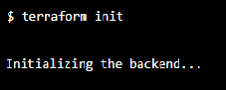

**Terraform Validate**

The validate command performs precisely what its name implies. It ensures that the code is internally coherent and examines it for syntax mistakes. Only the configuration files (*.tf) in the active working directory are examined. You must provide the -a recursive flag if you want to validate files inside of folders (for example, if you have a module/ directory).

$ terraform validate

**Terraform Apply**

Terraform apply command applies the changes defined in the configuration to your infrastructure. It creates or updates the resources according to the configuration, and it also prompts you to confirm the changes before applying them.

$ terraform apply

Terraform apply

**Terraform Destroy**

Terraform destroy command will destroy all the resources created by Terraform in the current working directory. It is a useful command for tearing down your infrastructure when you no longer need it.

$ terraform destroy

**Terraform Import**

Imports an existing resource into the Terraform state, allowing it to be managed by Terraform.

$ terraform import

**Terraform Console**

Opens an interactive console for evaluating expressions in the Terraform configuration.

$ terraform console

**Terraform Refresh**

This command updates the state of your infrastructure to reflect the actual state of your resources. It is useful when you want to ensure that your Terraform state is in sync with the actual state of your infrastructure.

$ terraform refresh

**Advantages of Terraform**

* **Declarative Configuration:** Terraform uses a declarative configuration language, which means that users define the desired state of their infrastructure resources, rather than the specific steps required to achieve that state. This makes it easier to understand and manage complex infrastructure deployments.
* **Support for Multiple Cloud Providers:** Terraform supports multiple cloud providers, as well as on-premises and open-source tools, which means that users can define and manage their infrastructure resources using a single configuration.
* **Reusable Infrastructure Code:** Terraform allows users to define their infrastructure resources in a reusable and modular way, using features such as modules and variables. This makes it easier to manage and maintain complex infrastructure deployments.
* **Collaboration and Version Control:** Terraform configuration files can be stored in version control systems such as Git, which makes it easier for teams to collaborate and track changes to their infrastructure.
* **Efficient Resource Management:** Terraform has features such as resource dependencies and provisioners that enable users to manage their infrastructure resources efficiently, minimizing duplication and ensuring that resources are created and destroyed in the correct order.

**Disadvantages of Terraform**

* **Complexity:**Terraform can be complex to learn and use, especially for users who are new to infrastructure automation. It has a large number of features and can be difficult to understand the full scope of its capabilities.
* **State Management:** Terraform uses a state file to track the resources it manages, which can cause issues if the state file becomes out of sync with the actual infrastructure. This can happen if the infrastructure is modified outside of Terraform or if the state file is lost or corrupted.
* **Performance:** Terraform can be slower than some other IaC tools, especially when managing large infrastructure deployments. This can be due to the need to communicate with multiple APIs and the overhead of managing the state file.
* **Limited Error Handling:**Terraform does not have robust error handling, and it can be difficult to diagnose and fix issues when they arise. This can make it difficult to troubleshoot problems with infrastructure deployments.
* **Limited Rollback Capabilities:** Terraform does not have a built-in rollback feature, so it can be difficult to undo changes to infrastructure if something goes wrong. Users can use the ‘ **terraform destroy** ‘ command to destroy all resources defined in the configuration, but this can be time-consuming and may not be feasible in all situations.